**1. INTRODUCTION**

**1.1. Project Overview**

The Gemini Historical Artifact System is a digital platform designed to preserve, manage, and provide access to historical artifacts from the Gemini space missions. These artifacts include spacecraft components, mission records, astronaut equipment, photographs, and other important historical materials. Many of these valuable artifacts are stored in physical form, making them vulnerable to damage, deterioration, and loss over time.

The system allows archivists and administrators to upload, update, and maintain artifact records, while researchers, students, and educators can easily search and access artifact information through a user-friendly interface.

The Gemini Historical Artifact System also helps protect space exploration heritage and ensures that valuable historical information is preserved for future generations. By using digital technologies, the system improves artifact accessibility, enhances preservation efforts, and supports learning and research activities related to Gemini space missions.

**1.2. Objectives**

The main objectives of the Gemini historical artifact description project are:

* To Store artifact information such as mission details, images, and descriptions in a secure system.
* To Allow researchers, students, and educators to search and view artifact data efficiently.
* To Provide accurate artifact information to help research and learning about Gemini space missions.
* To Enable archivists and administrators to upload, update, and maintain artifact records.

**2. IDEATION PHASE**

**2.1. Problem Statement**

I am a student, researcher, or museum curator trying to identify, analyze, and understand historical artifacts accurately, but there is no easy and fast way to get detailed and reliable artifact descriptions because artifacts require expert knowledge, historical context, and manual research, which makes me feel confused, slow in learning, and limited in accessing accurate historical information.

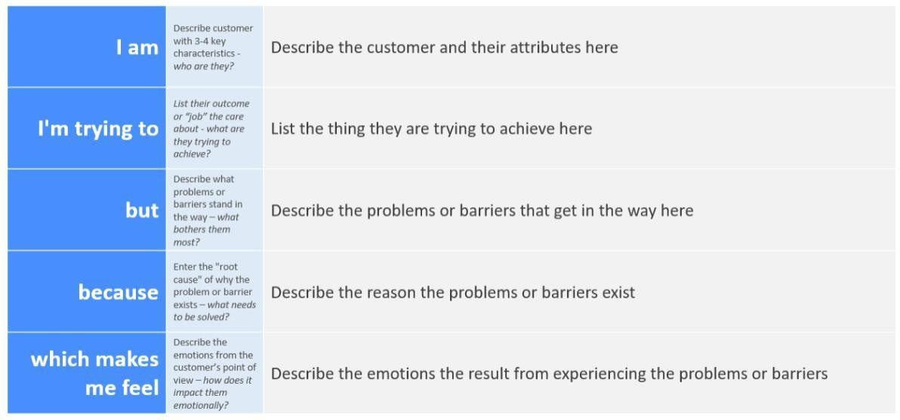**Example:**

|  |  |  |  |  |
| --- | --- | --- | --- | --- |
| I am | I'm trying to | But | Because | Which makes me feel |
| A researcher | identify and understand historical artifacts accurately | traditional identification methods are slow and require expert knowledge | artifacts need detailed analysis, historical context. | confused, inefficient, and limited in accessing accurate historical |
| I am a Museum Curator | I’m trying to preserve and manage Gemini historical | But there is no secure and efficient digital system to store | Because traditional storage methods | Concerned about losing valuable historical artifacts and information |

**2.2. Empathy Map Canvas**

# **Empathy Map Canvas:**

# The Gemini Historical Artifact Empathy Map focuses on understanding the needs, experiences, and motivations of historians, researchers, archivists, and space enthusiasts who interact with artifacts from the Gemini space program. These individuals are deeply committed to preserving and documenting important spacecraft components, mission records, photographs, and astronaut equipment that represent a crucial phase in space exploration history.

# Example:

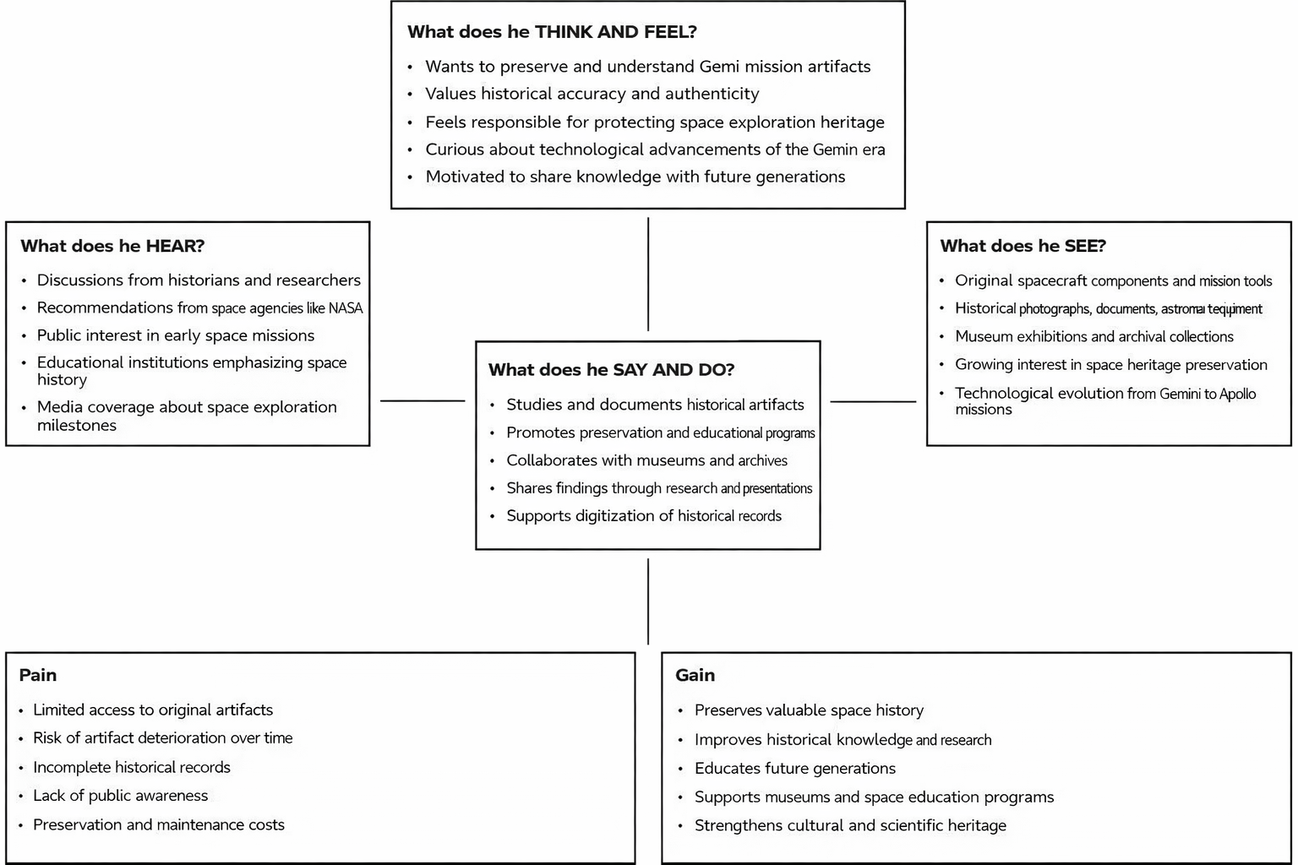

**Example**: Gemini historical artifact description

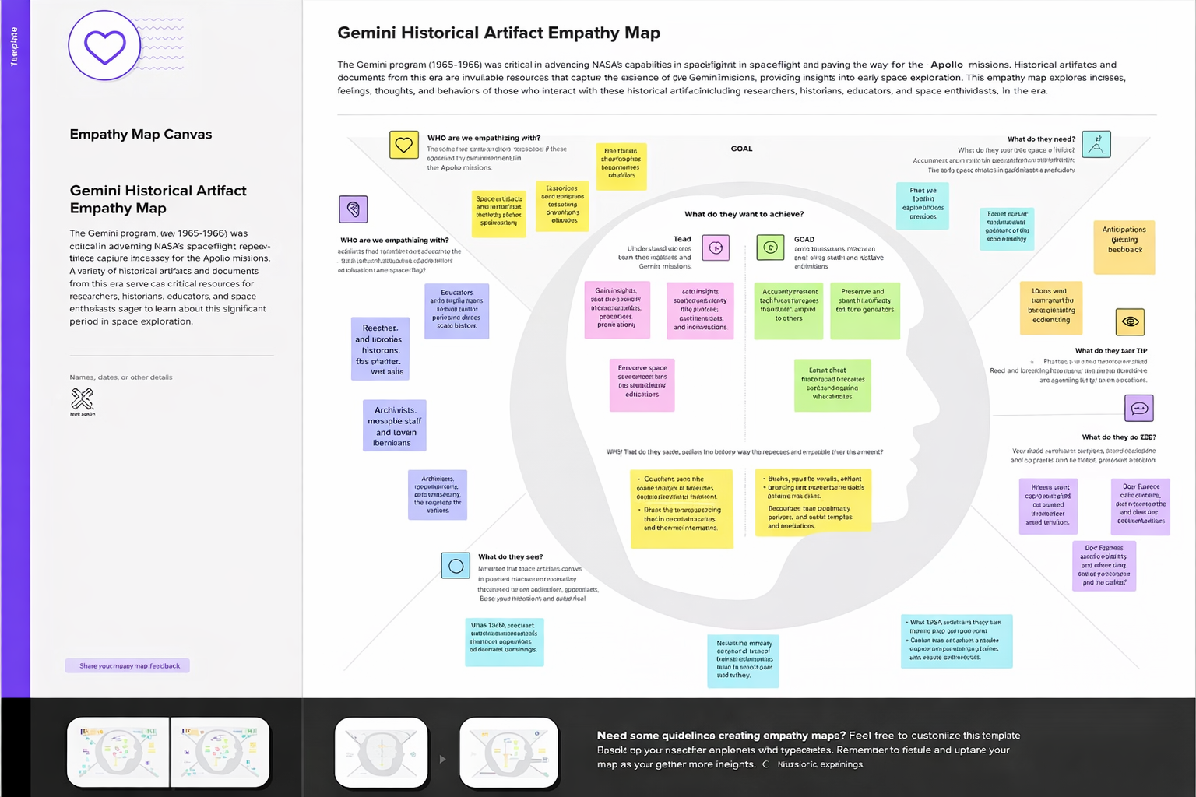

**2.3 Brainstorming**

**Brainstorm & Idea Prioritization:**

**Brainstorming for “Gemini historical artifact description”:**

Brainstorming for the project “Gemini Historical Artifact Description” focuses on exploring how artificial intelligence can help identify, analyze, and describe historical artifacts accurately. The main goal of this brainstorming session is to generate ideas on how Gemini can assist students, researchers, and museums in understanding the origin, cultural significance.

Gemini can solve this problem by using image analysis and natural language processing to examine artifact images and automatically generate detailed descriptions, including information about the artifact’s time period, material, origin, and cultural importance.

**Step-1: Team Gathering, Collaboration and Select the Problem Statement:**

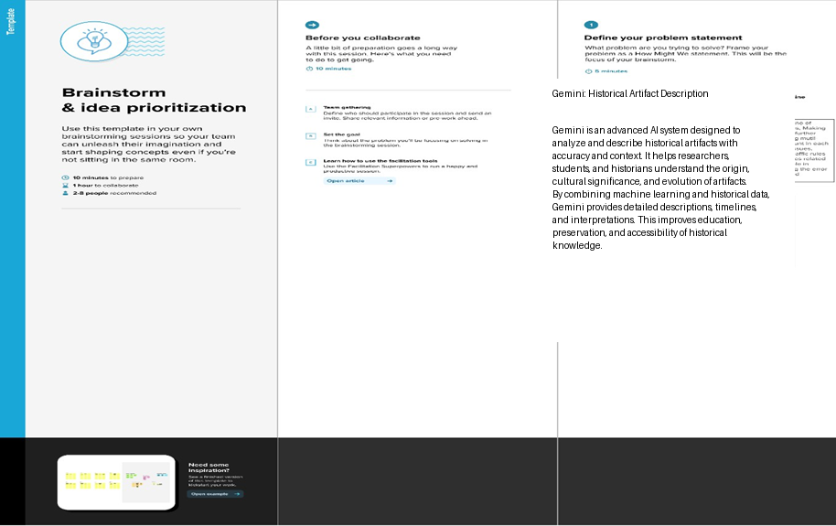

**Step-2: Brainstorm, Idea Listing and grouping:**

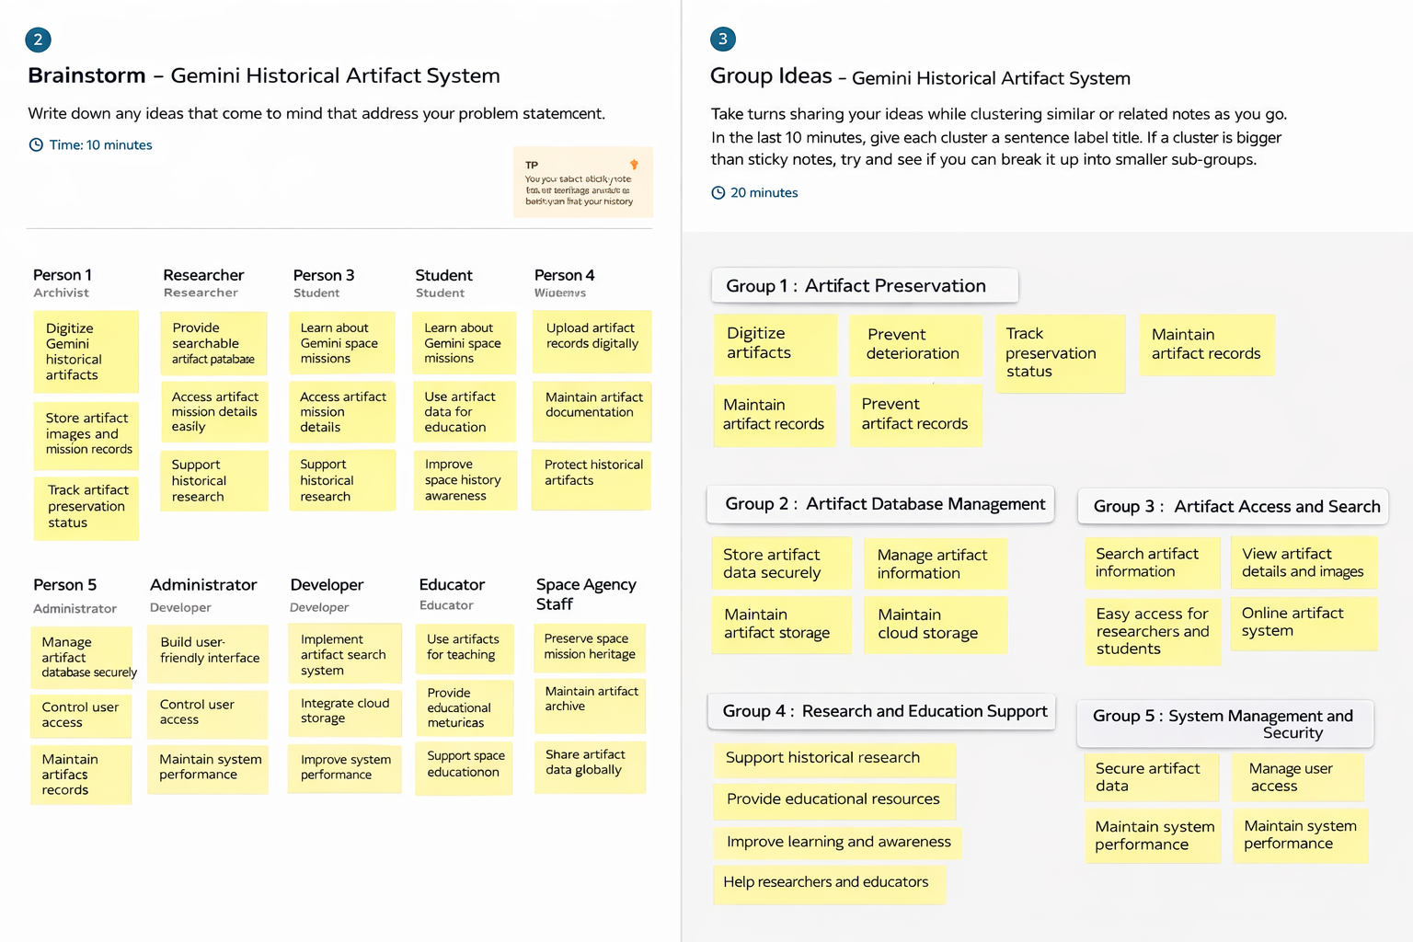

**Step-3: Idea Prioritization:**

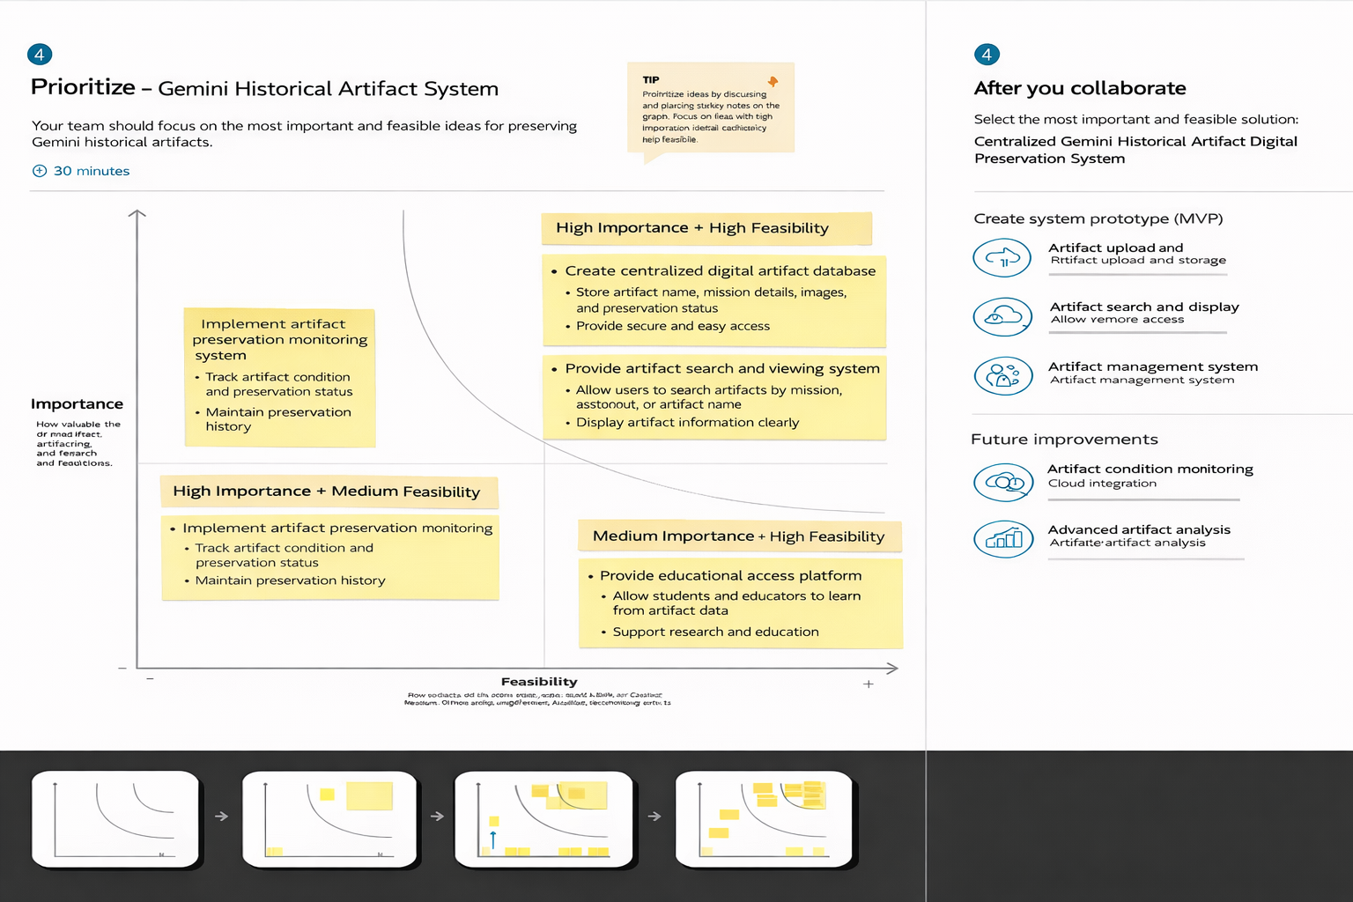

**3. Requirement Analysis**

**3.1. Solution Requirement**

**Functional Requirements:**

Following are the functional requirements of the proposed solution.

|  |  |  |
| --- | --- | --- |
| **FR No.** | **Functional Requirement (Epic)** | **Sub Requirement (Story / Sub-Task)** |
| FR-1 | Artifact Data Management | Upload and store Gemini historical artifact information including name, mission, description |
| FR-2 | Artifact Search and Retrieval | Allow users to search and retrieve artifact information quickly and accurately |
| FR-3 | Artifact Preservation Tracking | Track artifact condition, preservation status, and storage details |
| |  |  |  | | --- | --- | --- | | FR-4 |  | ccess, and maintain system security | | |  | | --- | |  |  |  | | --- | | User Management | | |  | | --- | | Allow administrator to manage users to control | |

**Non-functional Requirements:**

Following are the non-functional requirements of the proposed solution.

|  |  |  |
| --- | --- | --- |
| **FR No.** | **Non-Functional Requirement** | **Description** |
| NFR-1 | **Usability** | The system shall provide a simple and user-friendly interface that allows users to easily search and view artifact information |
| NFR-2 | **Reliability** | The system shall consistently store and retrieve artifact data accurately without data loss |
| NFR-3 | **Performance** | |  | | --- | |  |  |  | | --- | | The system shall display artifact information | |
| NFR-4 | **Availability** | The system shall be available and operational during research and educational usage |

**3.2. Data Flow Diagram**

**Data Flow Diagrams:**

The Gemini Historical Artifact Analysis System is designed to collect, store, process, and analyze historical artifacts from the Gemini space missions. The system begins with artifact data sources, which include important information such as artifact name, mission name, astronaut, mission date, artifact type, artifact condition, and storage location.

**Flow Diagram:**

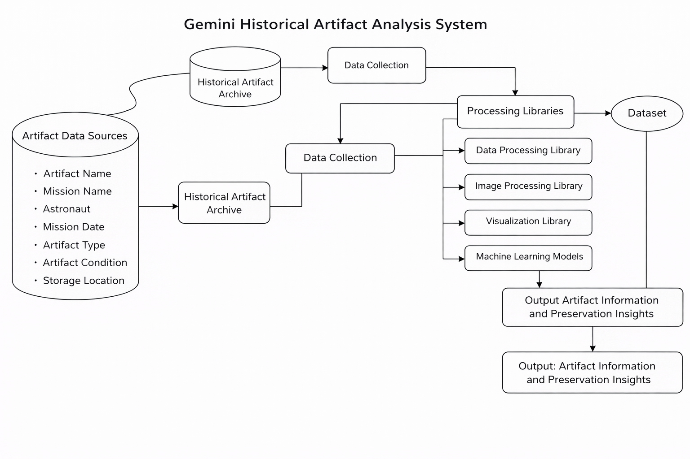

**User Stories**

Use the below template to list all the user stories for the product.

|  |  |  |  |  |  |  |
| --- | --- | --- | --- | --- | --- | --- |
| **User Type** | **Functional Requirement (Epic)** | **User Story Number** | **User Story / Task** | **Acceptance Criteria** | **Priority** | **Release** |
| Archivist | Artifact Data Management | USN-1 | As an Archivist, I want to upload and store Gemini historical artifact information | System allows artifact upload with name, mission, description, and images. Data is stored securely. | High | Sprint-1 |
| Researcher | Artifact Search and Access | USN-2 | As a Researcher, I want to search and view Gemini historical artifacts | System provides accurate artifact search results. Artifact details and images are displayed clearly. | High | Sprint-1 |
| Student / Public User | Artifact Viewing | USN-3 | As a Student, I want to view artifact information so that I can learn about Gemini space | Artifact information is displayed clearly. Images and mission details are accessible. | Medium | Sprint-2 |
| System Administrator | Artifact Database Management | USN-4 | As an Administrator, I want to manage artifact records so that the system remains accurate and secure. | Admin can add, edit, and delete artifact records. System maintains data integrity. | High | Sprint-1 |
| Museum Curator | Artifact Documentation | USN-5 | As a Curator, I want to document artifact present | System allows preservation status updates. | High | Sprint-2 |

**3.3. Technology Stack**

**Technical Architecture:**

The Deliverable shall include the architectural diagram as below and the

**Table-1 : Components & Technologies:**

|  |  |  |  |
| --- | --- | --- | --- |
| **S.No** | **Component** | **Description** | **Technology** |
| 1. | User Interface | Critical element designed for both Traffic Managers and everyday users, ensuring an intuitive and informative experience. | HTML, CSS, JavaScript |
| 2. | Application Logic-1 | Involves a robust backend system responsible for processing, analyzing, and managing traffic data. | Python |
| 3. | Database | Involves the storage and management of diverse traffic data for analysis. | File Manager, csv |
| 4. | File Storage/ Data | Involves managing diverse types of data, including raw traffic data, models, and configuration files. | Local System, Google Drive |
| 5. | Frame Work | It is a crucial part of our program as it is responsible for connecting the frontend with the backend. | Python Flask |

**Table-2: Application Characteristics:**

|  |  |  |  |  |  |  |
| --- | --- | --- | --- | --- | --- | --- |
| **S.No** | **Characteristics** | | **Description** | | **Technology** | |
| 1. | Open-Source Frameworks | Open-source frameworks can accelerate development and ensure the reliability of Gemini. | | Python’s Flask | |

|  |  |  |  |
| --- | --- | --- | --- |
| 2. | Scalability | Using cameras to collect data and to make models for specific locations. | Computer vision, dynamic databases. |
| 3. | Performance | Regular performance testing, monitoring, and optimization are integral components of the development and maintenance process | R squared, Root mean squared error, Root Mean Square deviation |
| 4. | Availability | Website can be made available all time in a webserver. This makes the website running without any issues | High speed Linux based webservers. |

**4. PROJECT DESIGN**

**4.1. Problem Solution Fit**

**Problem – Solution Fit Template:**

The Gemini Historical Artifact System addresses the critical problem of preserving and managing historical artifacts from the Gemini space missions. Many valuable artifacts, documents, and mission records are stored in physical form, making them vulnerable to deterioration, damage, and loss over time.

**Purpose:**

• To digitally preserve Gemini historical artifacts and prevent loss or deterioration.

• To store artifact information such as mission details, images, and descriptions in secure database.

• To provide easy access to artifact information for researchers, students, and educators.

• To support historical research and educational activities related to Gemini space missions.

**Template:**

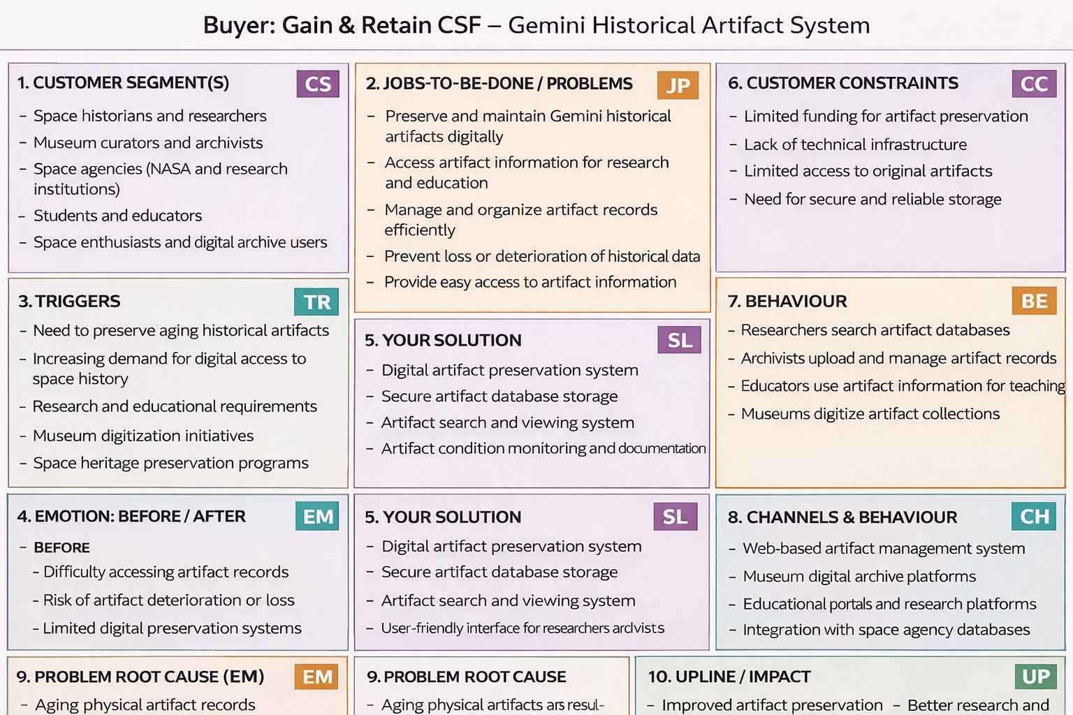

**4.2. Proposed Solution**

**Proposed Solution Template:**

Project team shall fill the following information in the proposed solution template.

|  |  |  |
| --- | --- | --- |
| **S.No.** | **Parameter** | **Description** |
| 1. | Artifact Data Collection | Collect artifact information from museums, NASA archives, historical documents, and digital libraries Gather artifact name, mission details, images, and descriptions |
| 2. | Data Processing | Convert collected artifact data into digital format and organize it properly Ensure artifact data is structured, accurate, and ready for storage |
| 3. | Artifact Database | |  | | --- | |  |  |  |  |  | | --- | --- | --- | | |  | | --- | | User interface to display artifact information Show artifact name, mission details, images, and preservation records |  |  | | --- | |  | | |
| 4. | Artifact Search System | Convert collected artifact data into digital format and organize it properly Ensure artifact data is structured, accurate, and ready for storage |
| 5. | Artifact Display Module | User interface to display artifact information  Show artifact name, mission details, images, and preservation records |
| 6. | User Management System | Manage users such as researchers, students, and administrators Control access and ensure system security |
| 7. | Preservation Monitoring | Track artifact condition and preservation status Help maintain and protect artifact information |

**4.3 Solution Architecture**

**Solution Architecture:**

The solution architecture of the Gemini Historical Artifact System is designed to digitally preserve, manage, and provide access to historical artifacts from the Gemini space missions. The system begins with artifact data collection from various sources such as museums, NASA archives, historical documents, and digital libraries. This data is then processed and converted into digital format to ensure accuracy and proper organization.

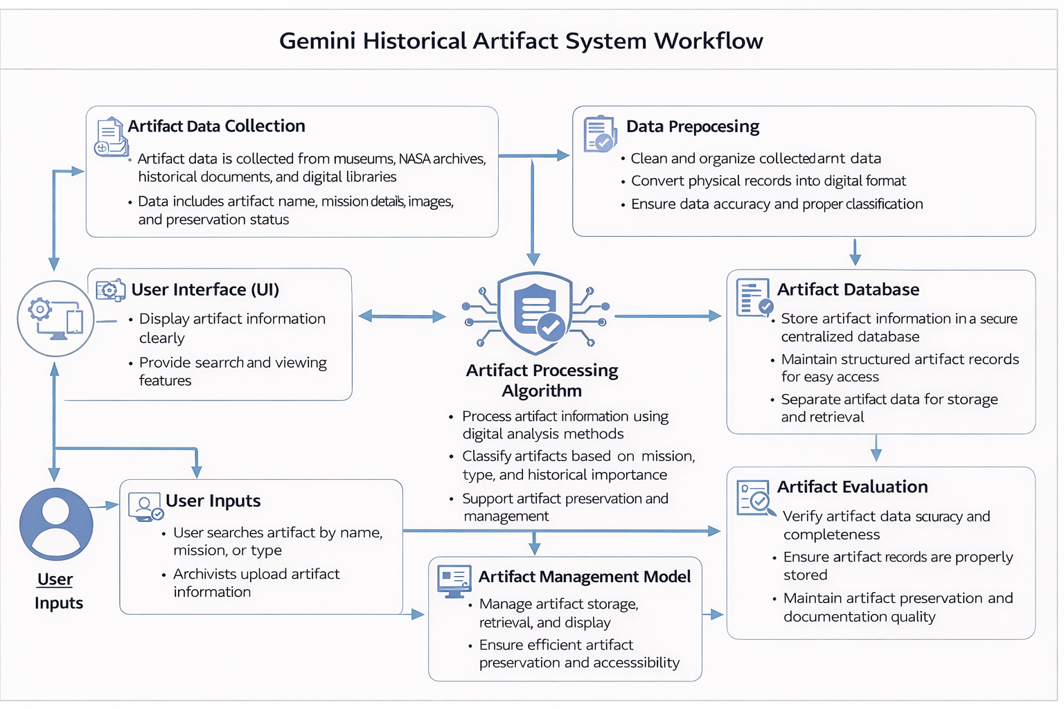

**5. PROJECT PLANNING & SCHEDULING**

**5.1. Project Planning**

**Product Backlog, Sprint Schedule, and Estimation (4 Marks)**

Use the below template to create product backlog and sprint schedule

| **Sprint** | **Functional Requirement (Epic)** | **User Story Number** | **User Story / Task** | **Story Points** | **Priority** | **Team Members** |
| --- | --- | --- | --- | --- | --- | --- |
| Sprint-1 | User Interface Setup | USN-1 | As a user, I can access a Streamlit-based interface to enter a recipe topic and word count. | 2 | High | All Team Members |
| Sprint-1 | Input Validation | USN-2 | As a user, I want the application to validate my inputs before generating the recipe. | 1 | High | All Team Members |
| Sprint-2 | AI Model Integration | USN-3 | As a user, I want the system to generate a recipe blog using the Gemini Flash Lite model. | 3 | High | All Team Members |
| Sprint-2 | Joke Generation | USN-4 | As a user, I want to see a programming joke while the recipe is being generated. | 1 | Medium | All Team Members |
| Sprint-3 | Output Display | USN-5 | As a user, I want to view the generated recipe blog clearly on the screen. | 2 | High | All Team Members |
| Sprint-3 | Deployment | USN-6 | As a user, I want the application to be deployed and accessible through the internet. | 2 | Medium | All Team Members |

**Project Tracker, Velocity & Burndown Chart: (4 Marks)**

| **Sprint** | **Total Story Points** | **Duration** | **Sprint Start Date** | **Sprint End Date (Planned)** | **Story Points Complete** | **Sprint Release Date (Actual)** |
| --- | --- | --- | --- | --- | --- | --- |
| Sprint 1 | 20 | 4 Days | 28 January 2026 | 31 January 2026 | 20 | 31 January 2026 |
| Sprint 1 | 20 | 4 Days | 28 January 2026 | 31 January 2026 | 20 | 31 January 2026 |
| Sprint 2 | 20 | 8 Days | 02 February 2026 | 09 February 2026 | 20 | 09 February 2026 |
| Sprint 2 | 20 | 8 Days | 02 February 2026 | 09 February 2026 | 20 | 09 February 2026 |
| Sprint 3 | 20 | 7 Days | 12 February 2026 | 18 February 2026 | 20 | 18 February 2026 |
| Sprint 3 | 20 | 7 Days | 12 February 2026 | 18 February 2026 | 20 | 18 February 2026 |

**6. FUNCTIONAL AND PERFORMANCE TESTING**

**6.1 Performance Testing**

**Test Scenarios & Results:**

|  |  |  |  |  |  |
| --- | --- | --- | --- | --- | --- |
| **Test Case ID** | **Scenario (What to test)** | **Test Steps (How to test)** | **Expected Result** | **Actual Result** | **Pass/Fail** |
| **FT-01** | Recipe Topic Input Validation | Enter valid recipe topic and leave field empty | Valid input accepted, error shown for empty input | As Expected | Pass |
| **FT-02** | Ingredient Input Validation | Enter valid ingredients and try empty/invalid inputs | Accepts valid input, shows warning for invalid input | As Expected | Pass |
| **FT-03** | AI Recipe Generation | Enter recipe topic and click “Generate Recipe” | Structured recipe with title, ingredients, and steps generated | As Expected | Pass |
| **FT-04** | Gemini API Connection Check | Trigger recipe generation with valid API key | API responds successfully and generates recipe | As Expected | Pass |
| **FT-05** | Programming Joke Feature | Generate recipe and check joke display | Programming joke appears along with recipe | As Expected | Pass |
| **PT-01** | Response Time Test | Measure time after clicking generate | Recipe generated within 3–5 seconds | Within Limit | Pass |
| **PT-02** | Multiple Request Handling | Generate multiple recipes sequentially | Application handles requests without crash | Stable | Pass |
| **PT-03** | Deployment Test | Access deployed app via browser | Application loads and works correctly online | Working | Pass |

**7. RESULTS**

**7.1. Output Screenshots**

The complete execution of Gemini historical artifact descriptionis represented step by step in the following screenshots.

**Step 1:** To run the Streamlit Application we have to use the command python streamlit run app.py in the terminal in path where the app.py file is located.

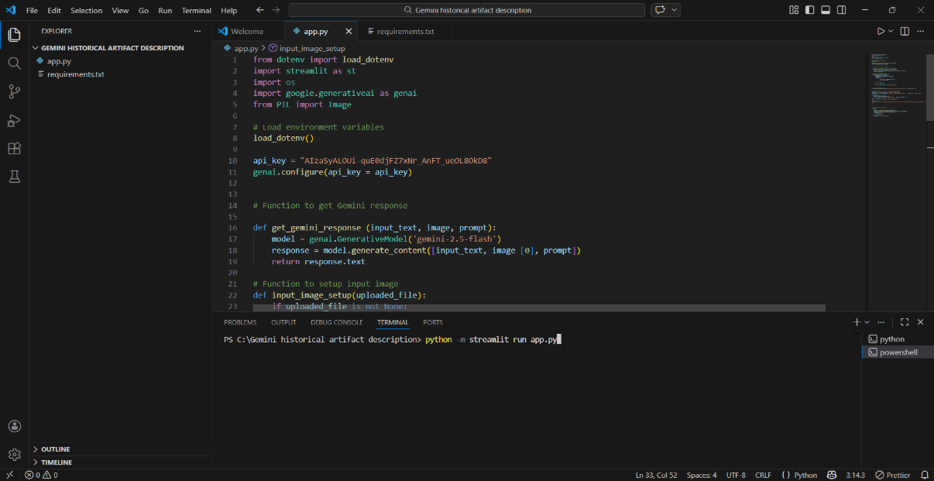

**Step 2:** After running the command in terminal, the code will get executed and the webpage will open directly. Another way to open webpage is that a localhost link will get generated in the terminal, we can access the webpage using that link.

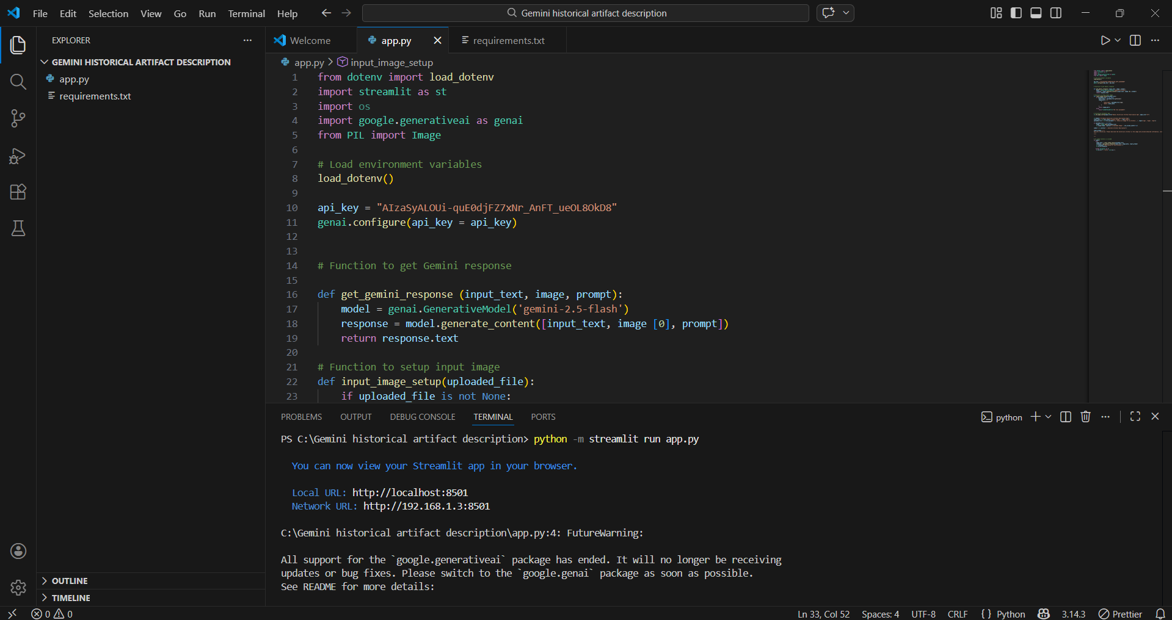

**Step 3:** The Streamlit webpage opens as shown in the figure given below. This is an automated webpage. No secondary HTML codes required to build this webpage. Python code itself consists the webpage building code.

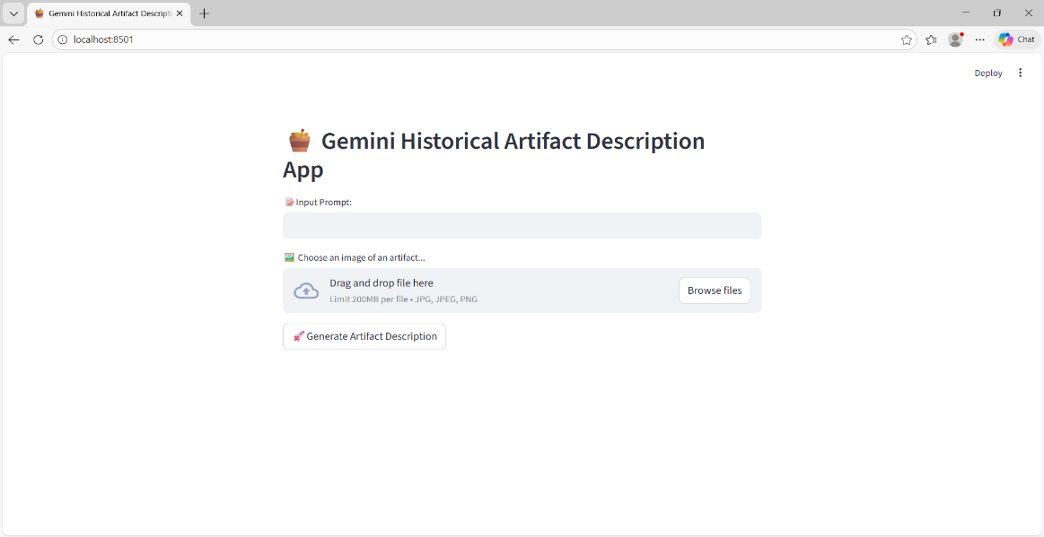

**Step 4:** After opening this portal it displays the Gemini Historical Description App, First we should type about any image description what ever we want contant in input prompt . It asks choose any image like wheather location etc. It generate based on the user inputs as shown in the following images

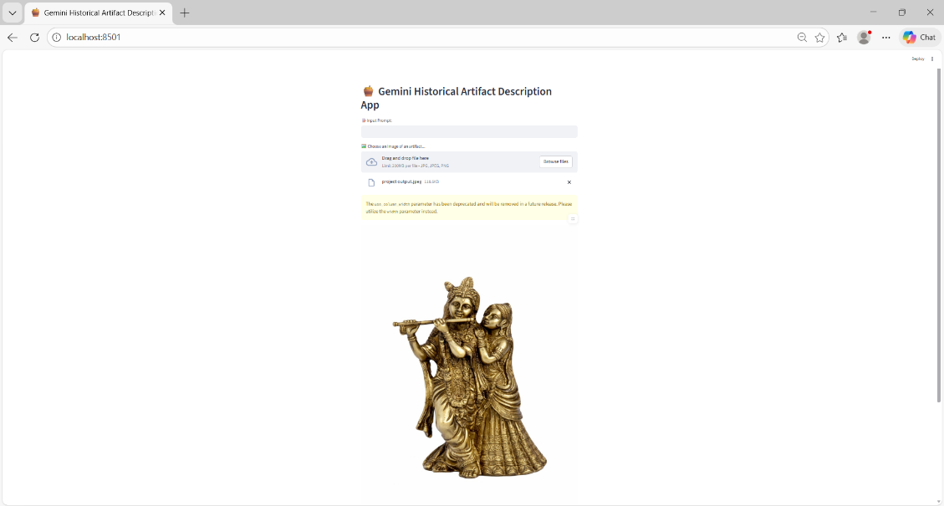

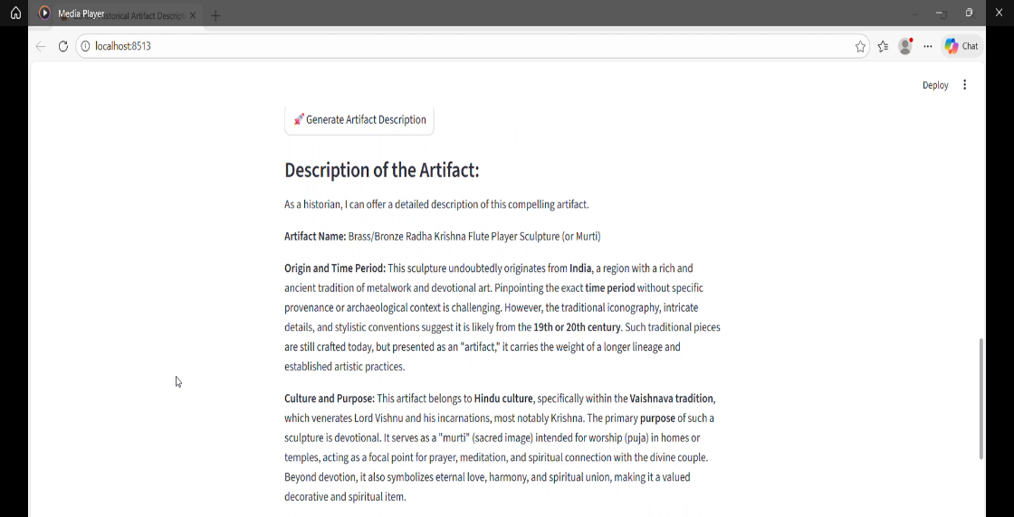

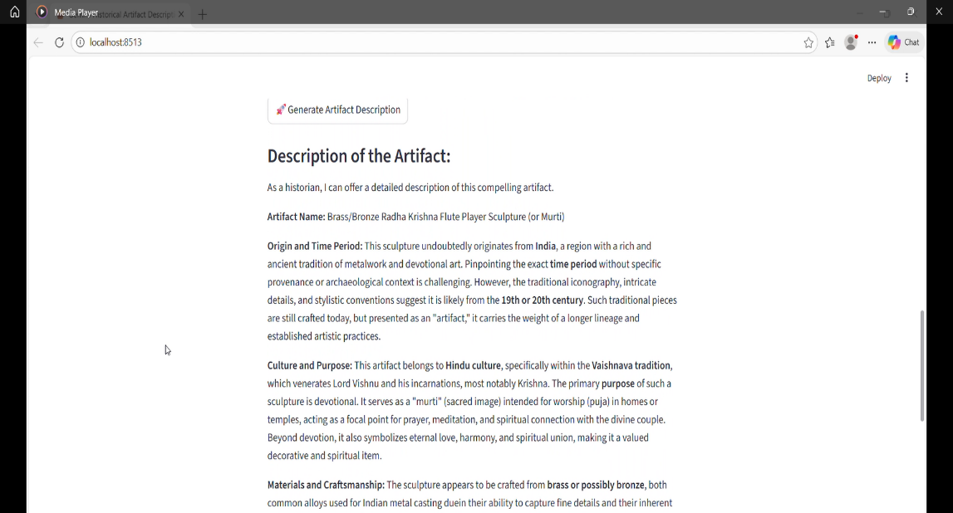

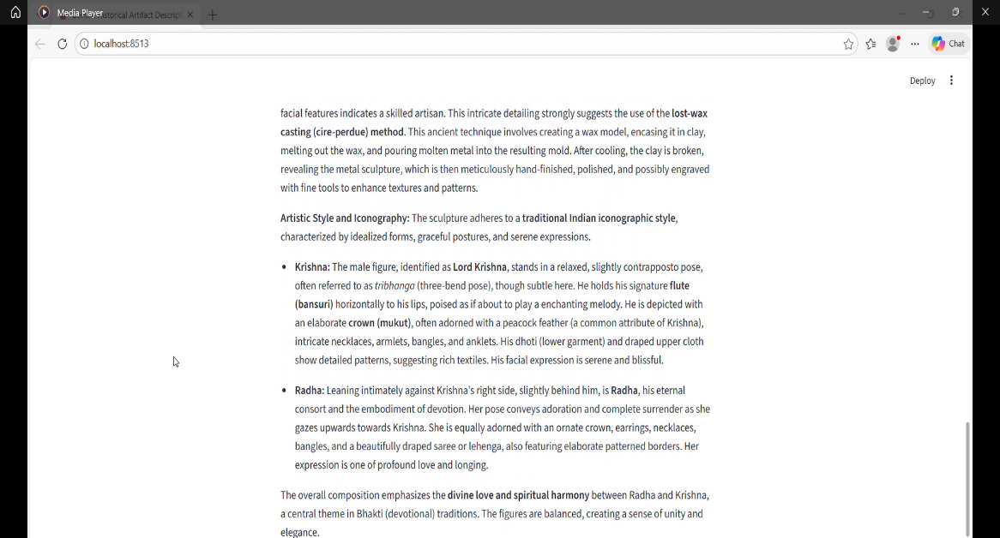

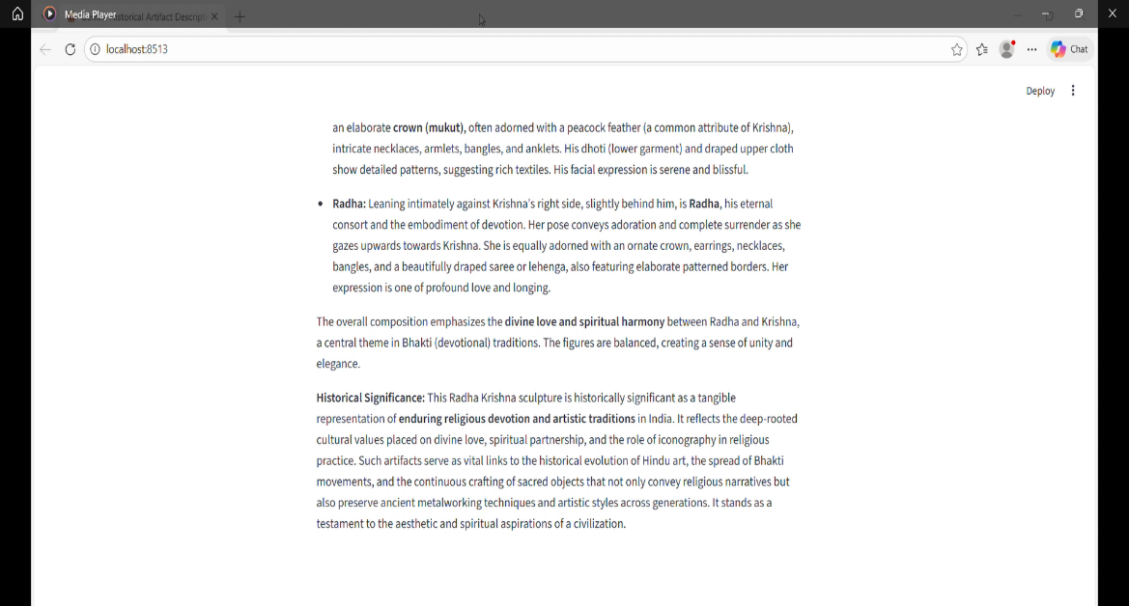

**8. ADVANTAGES AND DISADVANTAGES**

**Advantages**

* Generates artifact descriptions quickly and efficiently.
* Understands both images and text for accurate analysis.
* Saves time compared to manual research.
* Supports multiple languages for global users.
* Helps students and researchers in learning.
* Provides historical and cultural context.
* Can be integrated into apps and museum systems.

**Disadvantages**

* May sometimes give incorrect or incomplete information.
* Accuracy depends on image quality.
* Cannot recognize very rare or new artifacts well.
* Requires internet connection to work.
* Cannot fully replace human experts.
* May have data privacy concerns.
* Depends on training data quality.

**9. CONCLUSION**

Gemini is a powerful and useful tool for generating descriptions of historical artifacts quickly and efficiently. It helps students, researchers, and museums by providing detailed information and historical context through image and text analysis. This saves time and makes learning easier and more accessible. However, its accuracy depends on image quality and available data, and it may sometimes provide incorrect or incomplete information. Therefore, Gemini is best used as a supportive tool and cannot fully replace human experts such as historians and archaeologists.

**Github link**: <https://github.com/VijayaKumari-2004/Gemini-Historical-Artifact-System-implementation->

**Demo link:**

<https://drive.google.com/uc?id=1_61ooxVNp9jzMLOqN_UjYA1QzimbHQ2&export=download>